**Q # 1. Write a c code to produce the following output:**

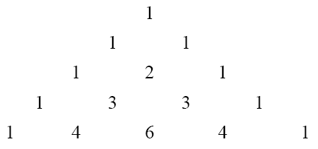

**Q # 2. Write a program to print all prime numbers from 1 to 300.**

A Prime Number can be divided evenly only by 1 or itself. And it must be greater than 1.

*Hint: Use nested loops, break and/or continue*

**Q # 3. Write a program to fill the entire screen with a smiling face. The smiling face has an ASCII value 1. [10]**

For this task you should know the height and width of your screen.

**Q # 4. Write a program to generate all combinations of 1, 2 and 3 using** for **loop. [10]** Sample Output:  
111  
112

113  
...  
**Q # 5. The natural logarithm can be approximated by the following series.**

**If** x **is input through the keyboard, write a program to calculate the sum of first seven terms of this series. Q # 6. Write a c code to produce the following output: [10]**

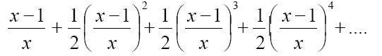

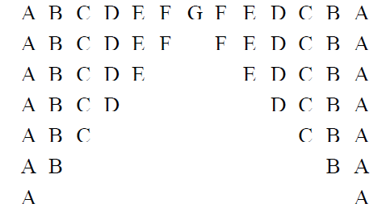

**Q # 7 Write a program to add first seven terms of the following series using a** for **loop:**

**Q # 8 Write a program to simulate the Collatz sequence for a given number n. The Collatz conjecture is defined as:**

If n is even, divide it by 2 n = n/2 (if n is even)  
If n is odd, multiply it by 3 and add 1 n = 3n + 1 (if n is odd) Repeat until n becomes 1.  
**The length of each chain should be printed at the end of the chain.** Sample Input: 13  
Sample Output:

**Q # 9 Write a program to check whether a given number is an Armstrong number using a loop.**

(An Armstrong number is a number that is equal to the sum of its digits raised to the power of the number of digits.

For example, 153 is an Armstrong number: 13+53+33=15313+53+33=153

**Q # 10 Write a program that calculates the Least Common Multiple (LCM) and Greatest Common Divisor (GCD) of two numbers using loops**

*Note: It is an independent assignment. Discussion with your class fellows and your teacher is encouraged but plagiarism is strictly prohibited. Anyone involved in plagiarism would get zero marks in this assignment.*